CURRICULUM VITAE

Basic information
Personal Data | 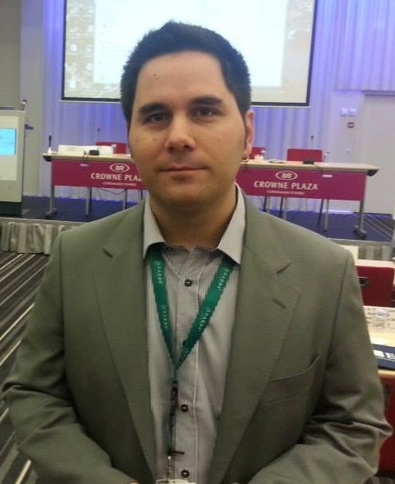
Name and surname | Gavrilo Belaćević
Date of birth | February 08, 1985
City of residence | Belgrade, Serbia
Gender | Male
Marital status | Married + 2 children
Passport | Serbian
Contact Info
Cell phone | +381603887388
E-Mail | gavrilo@belacevic.com
Web Site | http://www.belacevic.com

Education
Studies
Title  Name of University | Bachelor of Electrical Engineering (B.E.E.)  University of Belgrade, School of Electrical Engineering
City | Belgrade - Serbia
Course | RTI - Department of Computer Science and Informatics
Started / ended | 2003 / 2013
Courses / seminars
2009. | Software Design-From-Analysis  (Michalis Koniotakis, Oracle ACE, lecture – 10 days)
2008. | Oracle ADF 11g  (Andrejus Baranovskis, Oracle ACE Director, lecture - 8 days)
2004. | IBM EP59: IBM Project Management Concepts  (Serbian Business Systems)
2004. | Microsoft course 2274B: Managing a Microsoft Windows Server 2003  (University of Belgrade, School of Electrical Engineering)

Working Experience
12/2012 - present
Company name | Seavus d.o.o (http://www.seavus.com)
Job position | Senior Software Developer / Team Lead
Job description | Full time job as Senior Software Developer, leading a team of four developers on a money transfer (SWIFT) project migration / re-factoring for an international client. Responsible for communication with clients, defining client’s needs and requests and turning them into business analysis and further to technical design. Supervising development, code review and release process also made integral part of everyday activities, apart from the regular development itself.  Technologies used:  J2SE 7, Spring MVC, JDBC, ThymeLeaf on Tomcat 7 Application Server, MySQL and Apache Derby databases.
4/2011 - 12/2012
Company name | ArsBlue d.o.o (http://www.arsblue.rs)
Job position | Senior Software Developer
Job description | Full time job as Senior Software Developer, working for the company’s Card Management Team. Responsible for developing, maintaining and improving functionality of company’s products for financial transactions / assets using J2EE, as well as for application deployments and configuration.  Technologies used:  STRUTS, Spring, Hibernate / JSP, on WebSphere 6.1 Application Server and IBM DB2.
11/2008 – 4/2011
Company name | European Dynamics LUX (http://www.eurodyn.com)
Job position | Software Developer / Consultant / Software Designer
Job description | Full time job as Software Developer, working as external/consultant at  MedNet International on MedNeXt application migration project.  Responsible for developing, maintaining and improving functionality of  one of the leading Health Insurance Management Applications using  Oracle ADF 11g Framework, as well application deployments and  Security integration. Working directly with client’s development team and along Oracle ACE Director on a pioneering project using Fusion Middleware (http://www.oracle.com/us/corporate/press/425153)  Technologies used:  Oracle ADF 11g / JSF, on WebLogic 10.3 Application Server and Oracle database.
08/2007 – 11/2008
Company name | ArsBlue d.o.o (http://www.arsblue.rs)
Job position | Software Developer / Consultant
Job description | Full time job as Web Developer, working as external/consultant at  Ministry of Internal Affairs, being one of the leading men on Digital  Personal Documents project. In charge of many sectors, such as: Web  Application itself, Data Structure and Security Level (Roles/Policies and  Error Prevention/Recovery), as well as application deployments and configuration.  Technologies used:  STRUTS / EJB 2.0 / JSP, on WebSphere Application Server and Oracle database.
05/2003 – 08/2007
Company name | Freelancing (http://www.belacevic.com)
Job position | Developer / Web Designer
Job description | Creator of more than 15 complete solutions for dynamic and static Web Sites, as well as 3 desktop applications for different clients, mostly companies from Serbia, but also Angola, Brazil and Bosnia.  Technologies used:  PHP / MySQL, HTML / AJAX / JavaScript / CSS.

Experience with tools / environments / programming languages and frameworks
Development tools | IntelliJ IDEA  Eclipse  WebSphere Software Developer (IBM Rational Developer)  Oracle JDeveloper  NetBeans  TOAD for Oracle  Oracle SQL Developer
Application Servers | Tomcat Server  WebLogic Application Server  WebSphere Application Server
Databases | ORACLE (9i, 10g)  IBM DB2 (8, 9)  MySQL  PosgreSQL
Frameworks / lang. | J2SE/J2EE, Struts, EJB, Spring (MVC), Hibernate, ADF, JSF, ThymeLeaf, PHP, SQL, JavaScript / jQuery, AJAX, HTML, XML, CSS
Security | IBM Tivoli Access Manager (pdAdmin and Delegate)  Active Directory LDAP

Foreign languages
Serbian | Native
English | Excellent knowledge of spoken and written language
Italian | Good knowledge of spoken and written language (3 courses passed)
German | Weak knowledge (2 courses passed)
Spanish | Weak knowledge (3 courses passed)
Greek | Weak knowledge (Learned through living in Greece)

Personality
Ambitious, very communicative, able to work both alone and in a team. Proven to be able to work under pressure and to take responsibility for important decisions. Always willing to improve, learn and progress. Feeling comfortable working as technical consultant / external.

